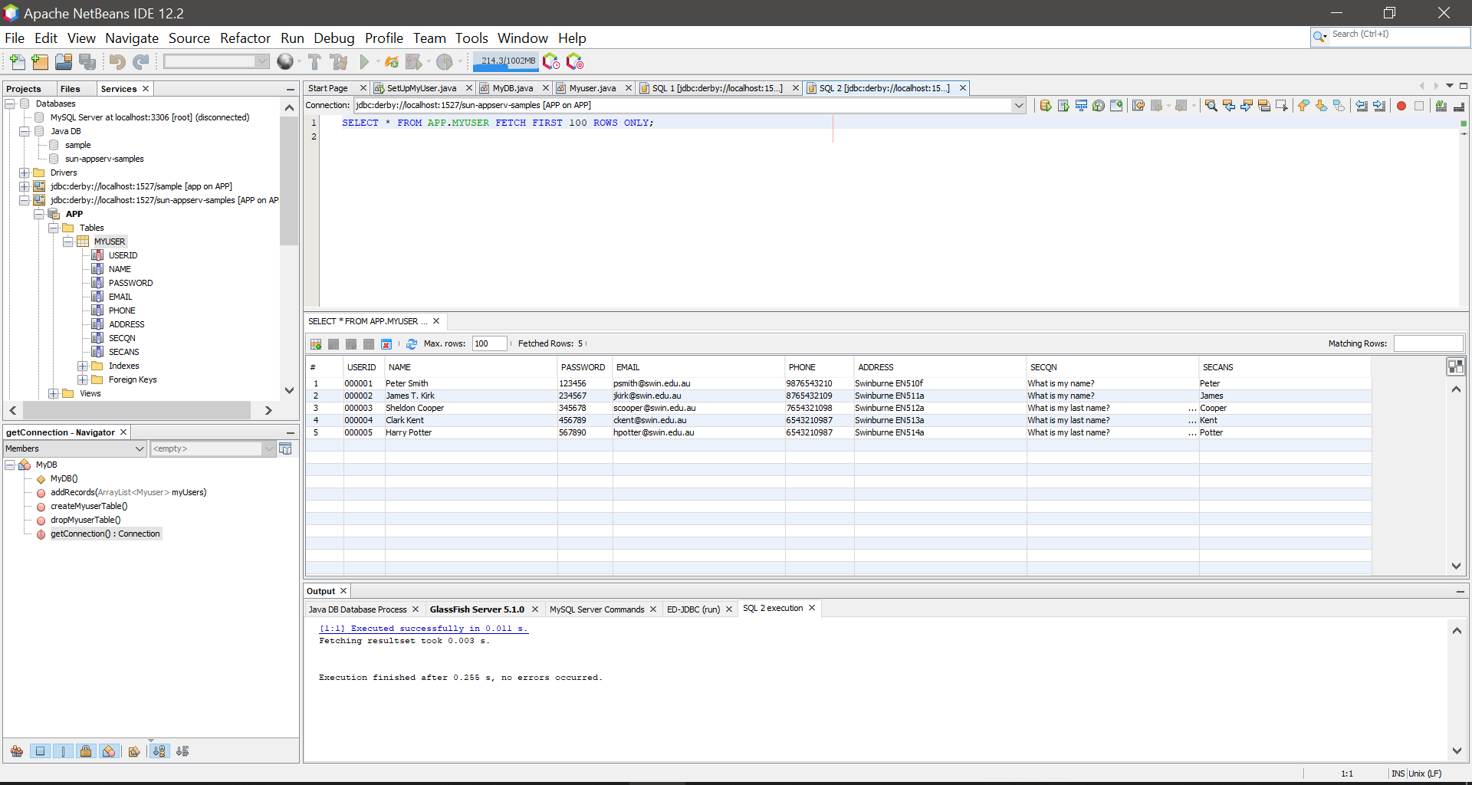After step 1 was done:

The picture for codes for step2:

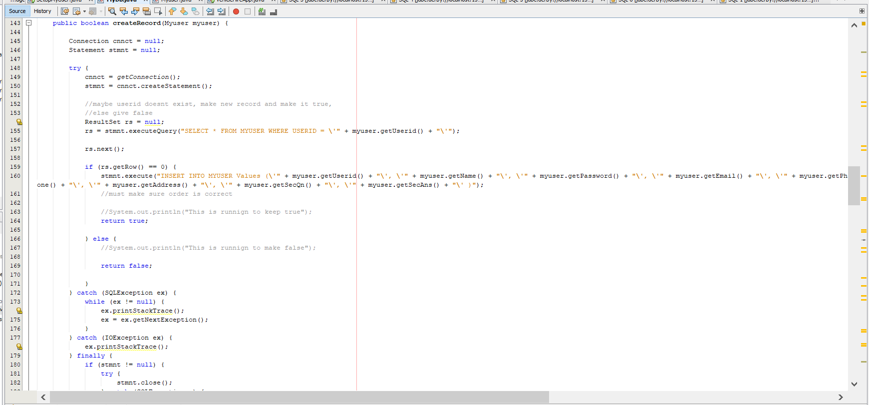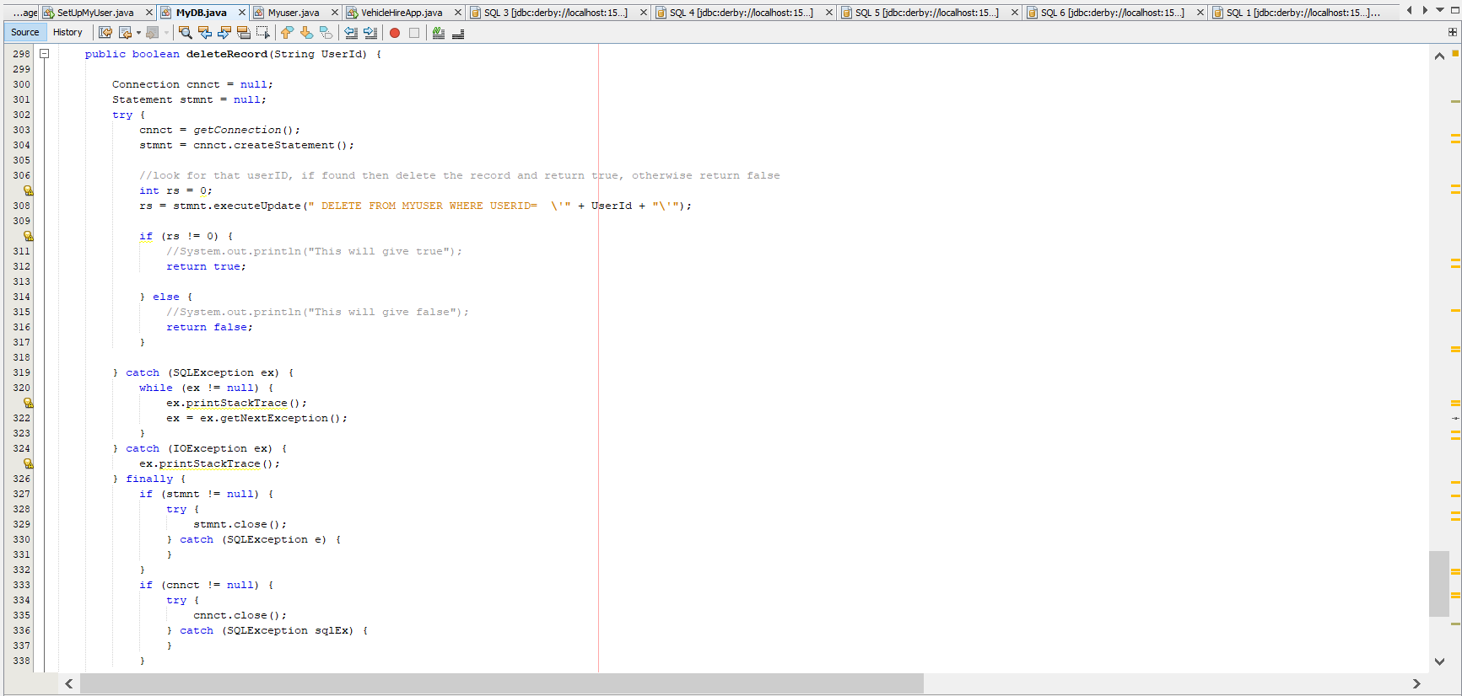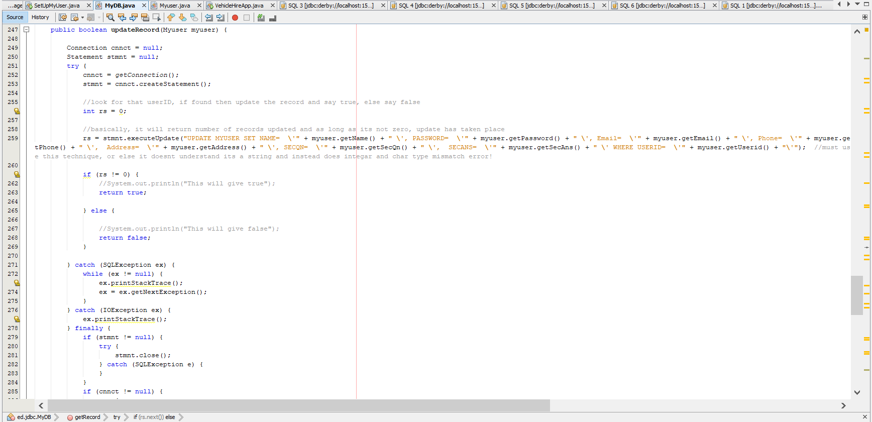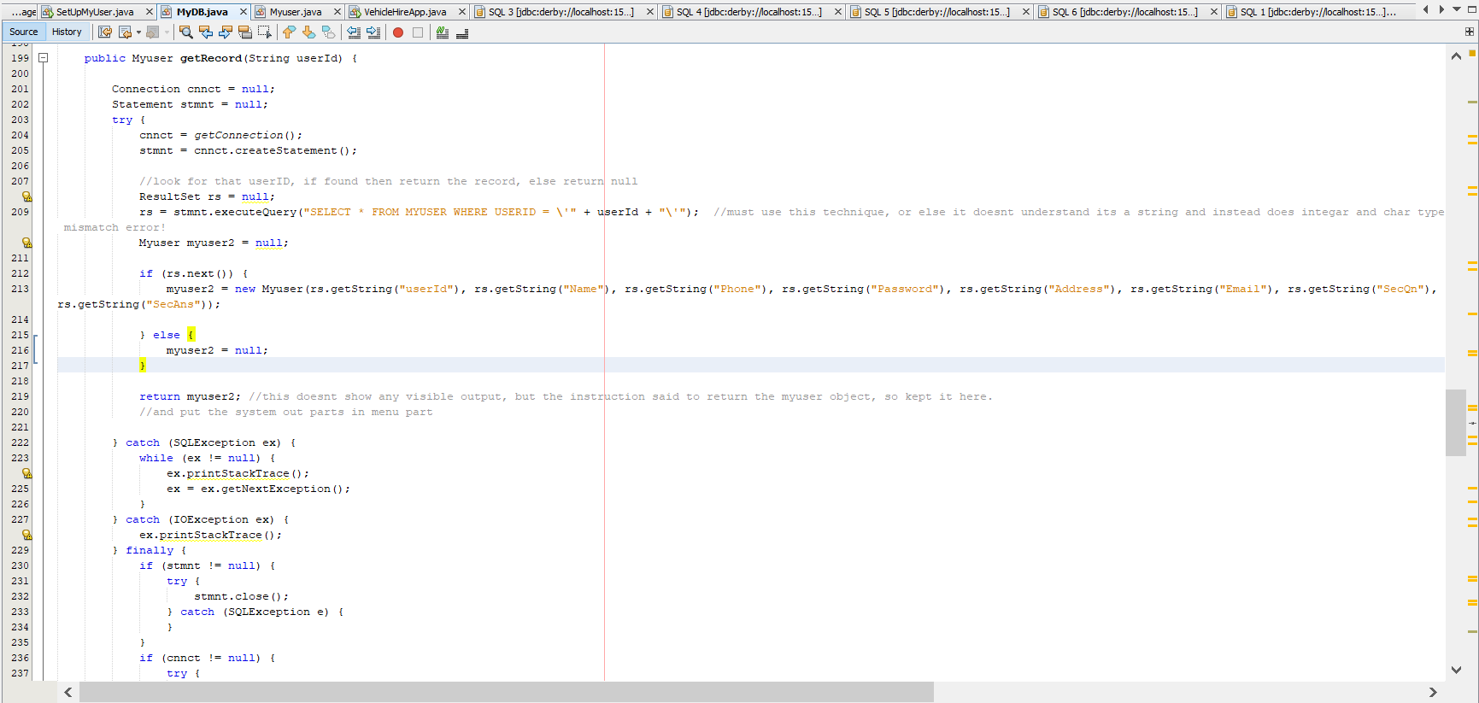

Step 3 pictures:

New record entry both cases:

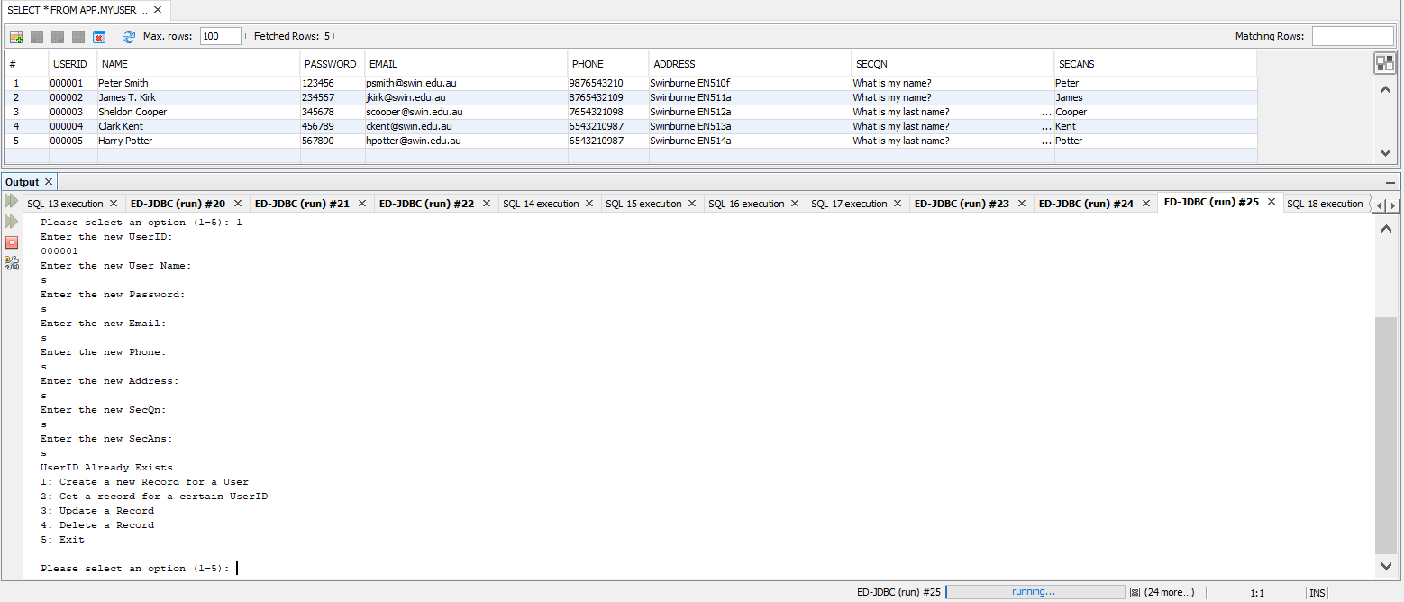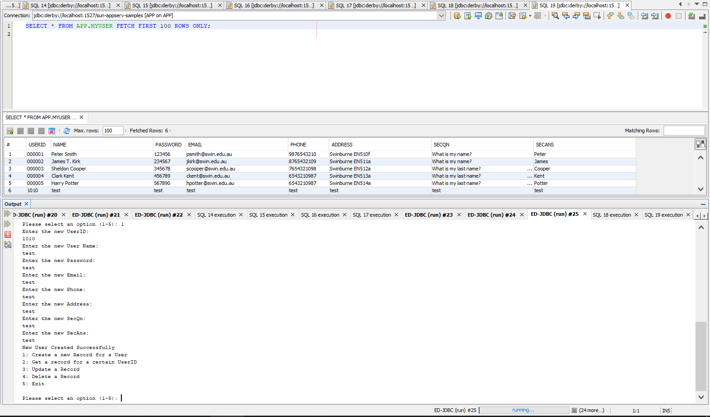

Get record both outcomes:

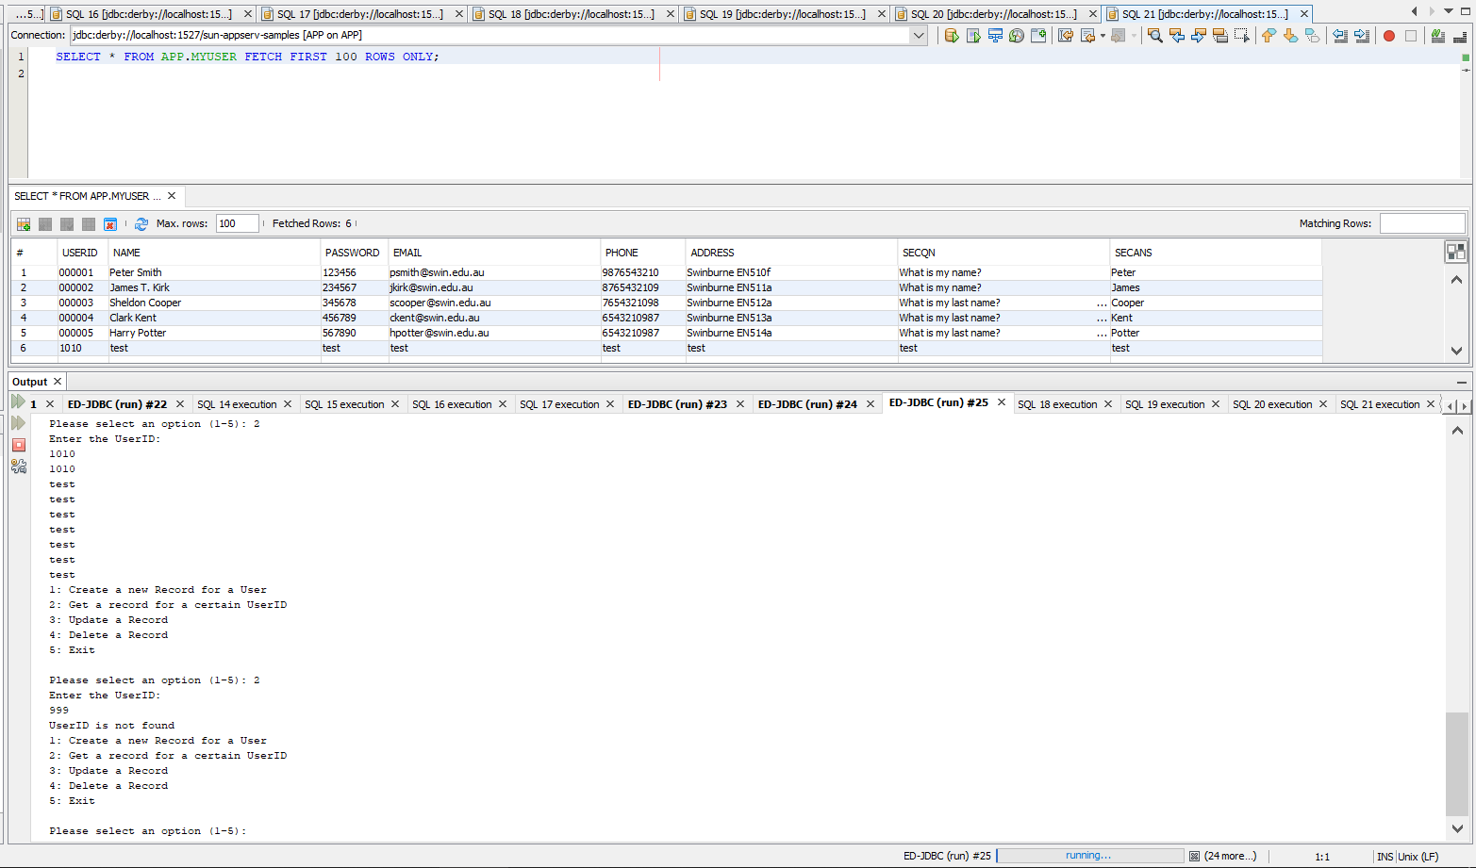

Delete record both outcomes:

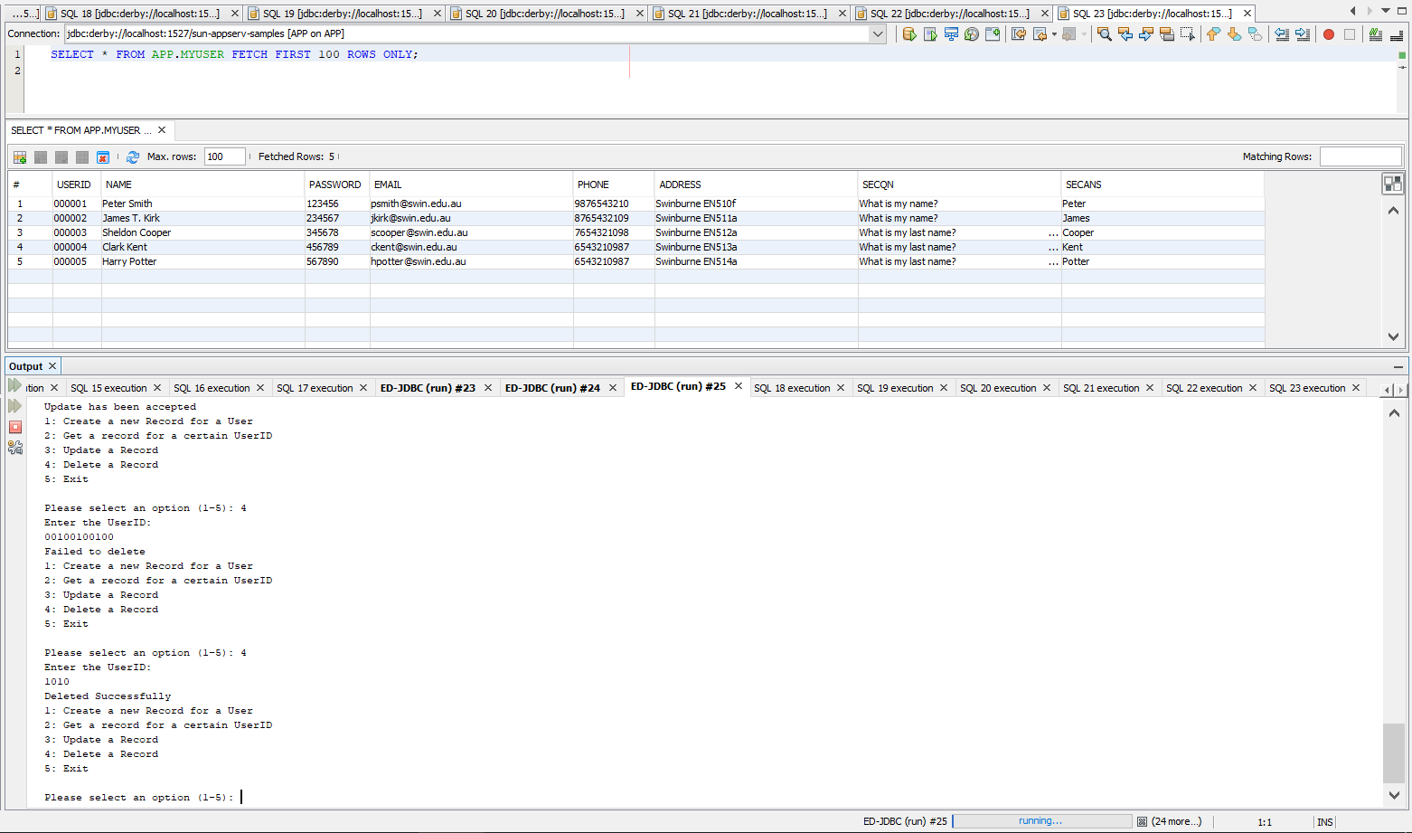

Update record both outcomes:

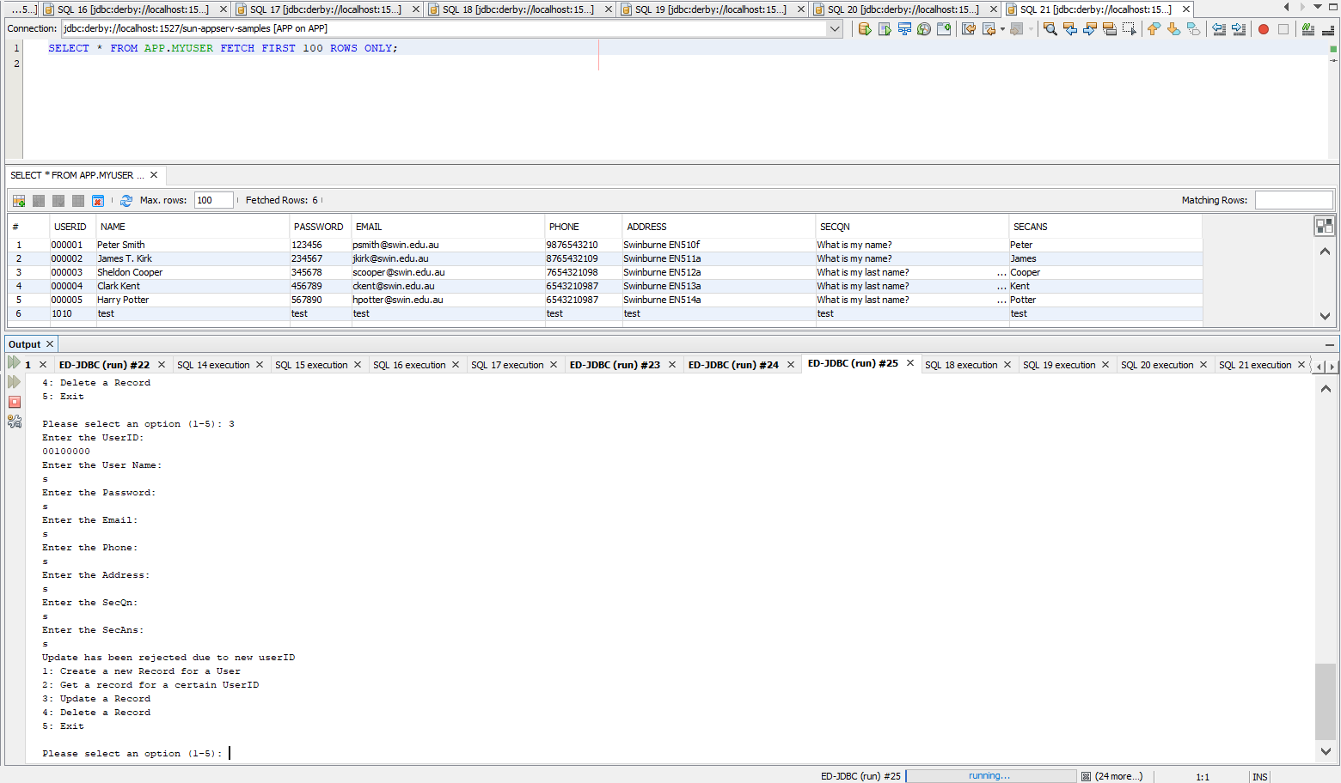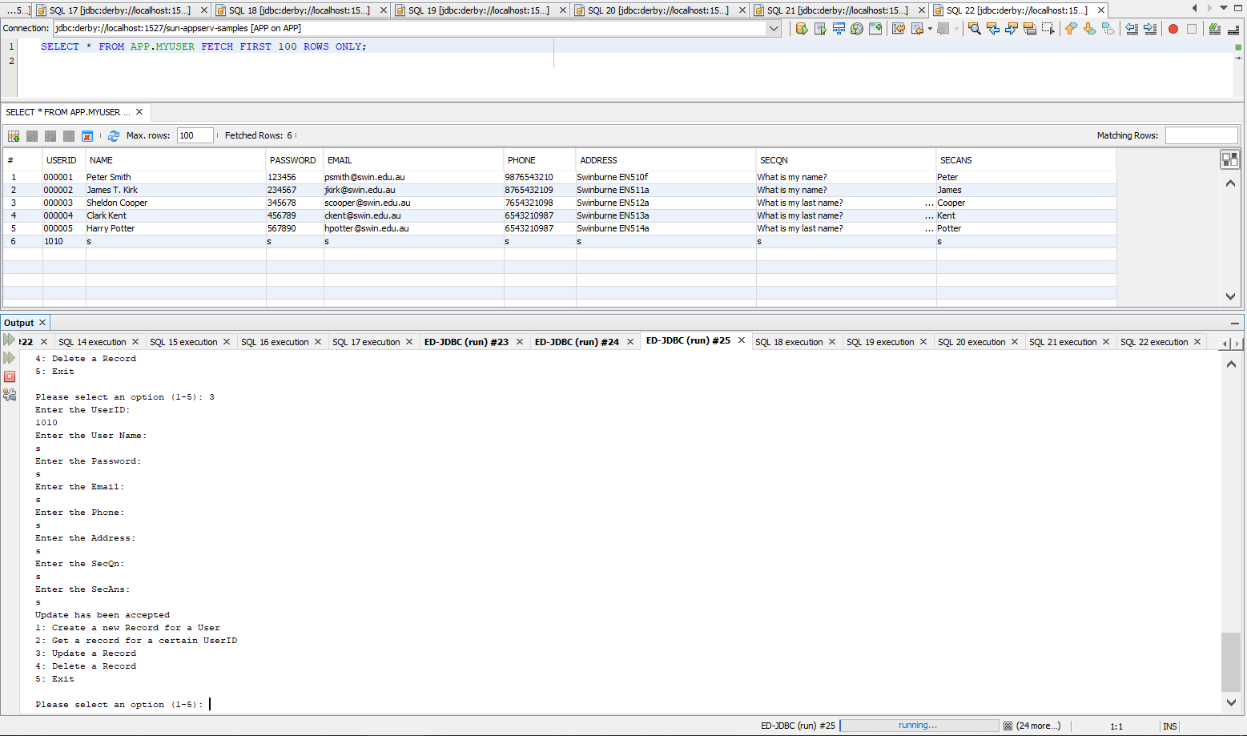

Step -4:

4.1: DTO means data transfer object and DAO means data access object. Myuser class is a DTO as it holds the pattern to create individual user, instead of making them separately by calling userid, name,etc.

4.1.1: DAO basically does some certain, specific data operations without exposing details of the database itself. And since myuser is not a DAO, MyDB must be the DAO.

4.2: No. That’s because myuser.setname is a method of the myuser class which is not a dao. Thus it can’t access the database when called in the program.

4.3: No. That’s because even though myDB is a DAO, it calling method of myuser class which is not a dao. Thus it can’t change value in the database.